

SCHOOL OF COMPUTING AND INFORMATICS
BACHELOR OF SCIENCE IN INFORMATION TECHNOLOGY
UNITE TITLE: ETHICAL HACKING
UNITE CODE:
PROJECT TITLE: SECURITY AND ENUMERATION

SUBMITTED BY: MAINA JOSHUA
REG. NO: BSCCS/2024/47667

SUPERVISOR: MR. MICHAEL NYORO

Contents
1 PROJECT TITLE: SECURITY AND ENUMERATION 2
1.1 Selected Technologies 2
1.2 Online portfolio 2
1.3 Importance 2

PROJECT TITLE: SECURITY AND ENUMERATION

Selected Technologies
- Nmap
- WHOIS
- DNS LOOK-UP
- Shodan
- DNS Checker

Online portfolio
Github
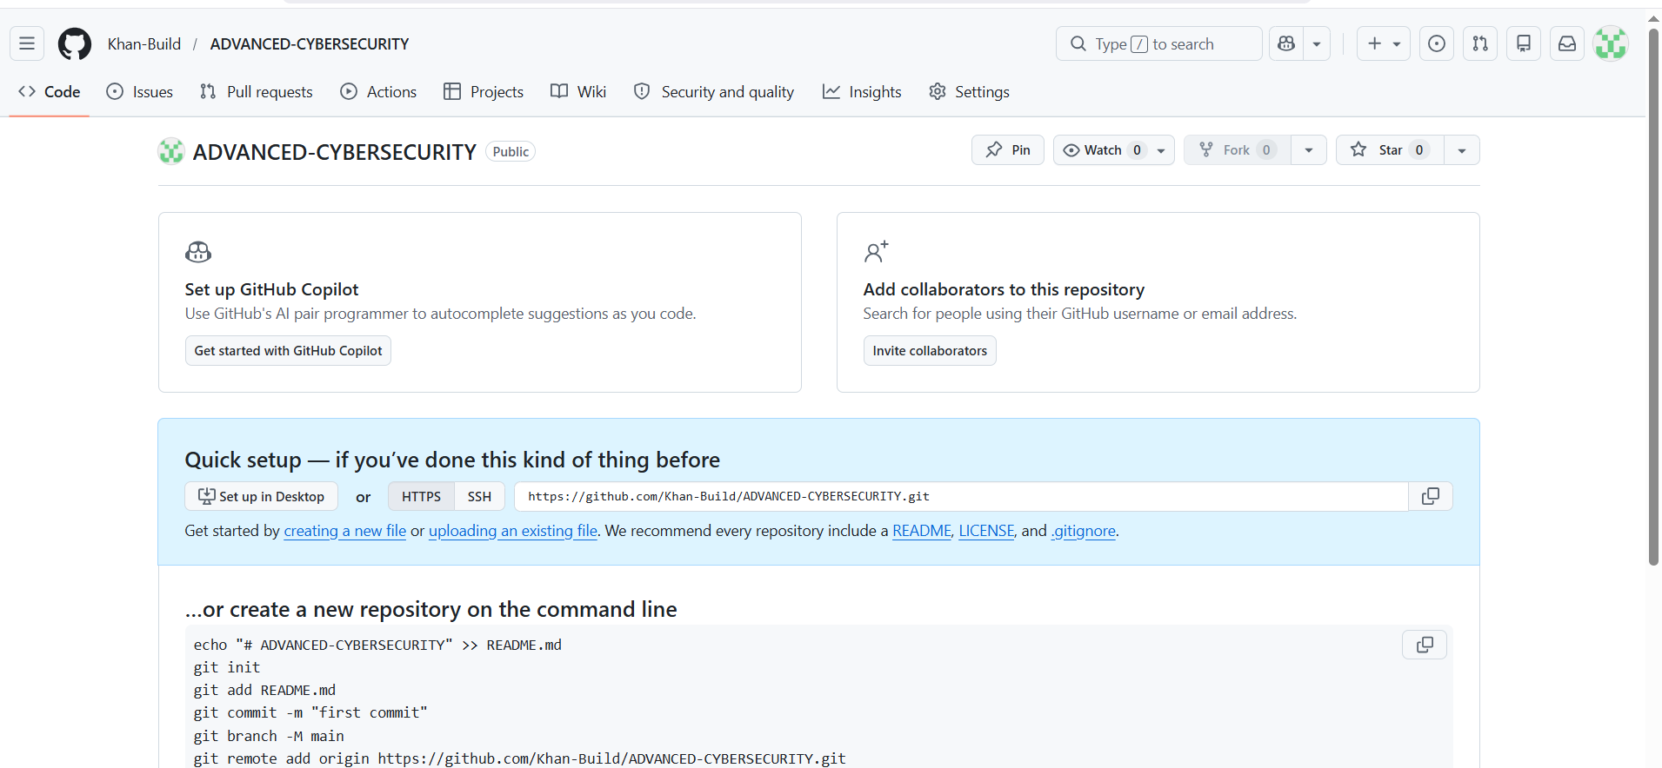
https://github.com/Khan-Build/ADVANCED-CYBERSECURITY
Github Repo created

Importance
This Encourages:
- Identify active hosts on a network.
- Discover open ports and exposed services.
- Determine operating systems and device types.
- Identify technologies used by websites and applications.
- Detect outdated software and unsupported systems.
- Map the attack surface of an organization.

Week 1

CRYPTOGRAPHY ENVIRONMENT SETUP
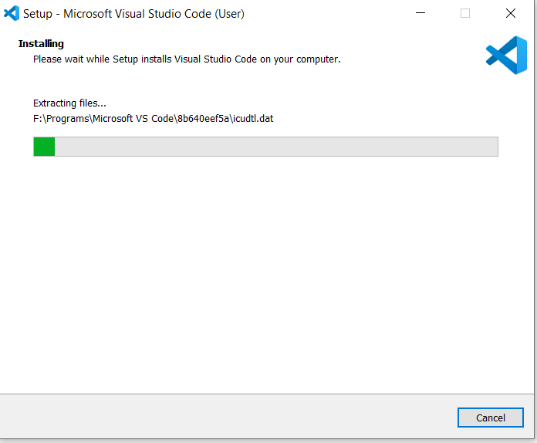
Figure 1Installation of VS Code
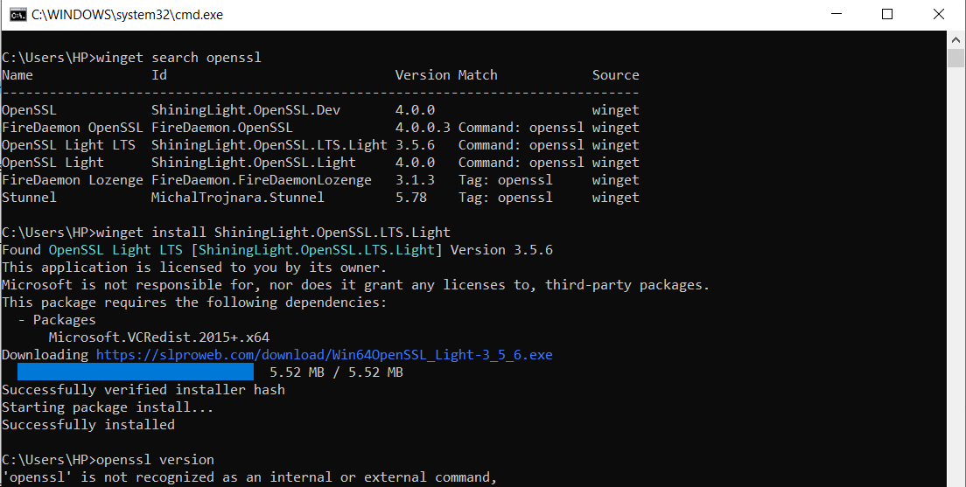Figure 2:open ssl Installation Test
Figure 3Local Encryption Script Execution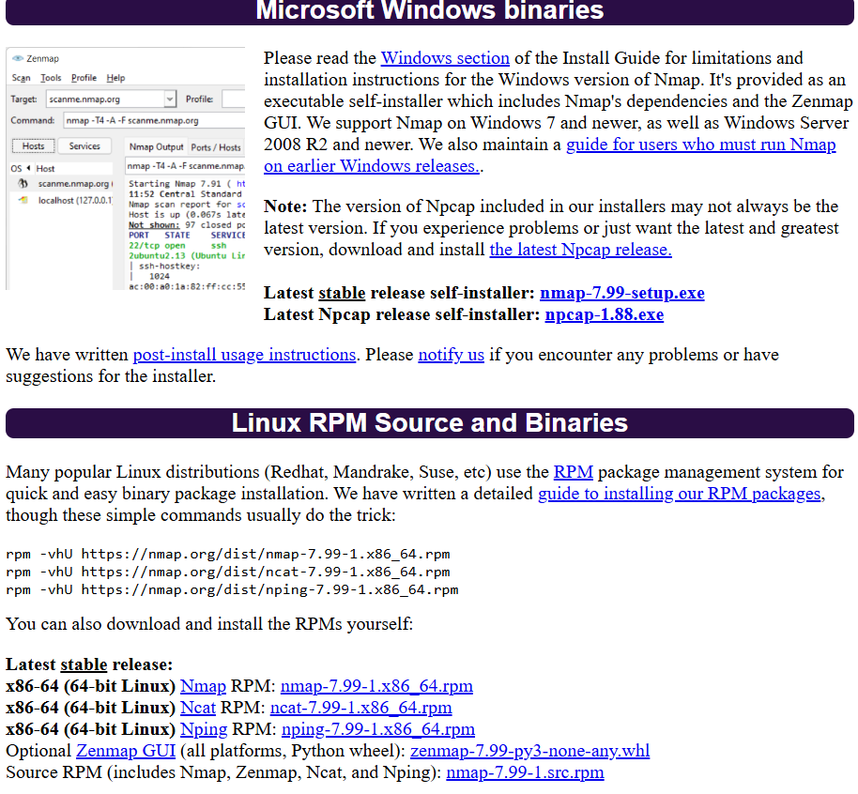
Figure 4Downloading tool from official Site
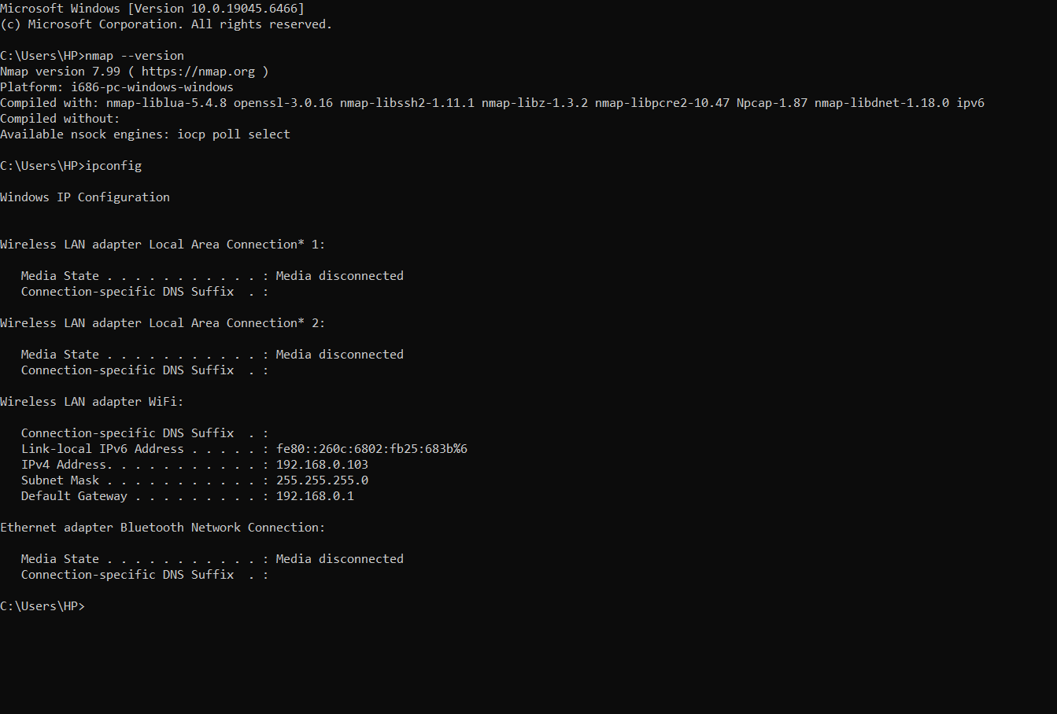
Figure 5 First Scan and confirmation of installation

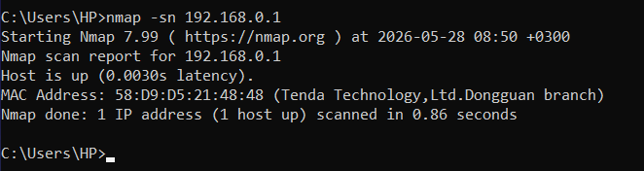
Figure 6 Computer Scan
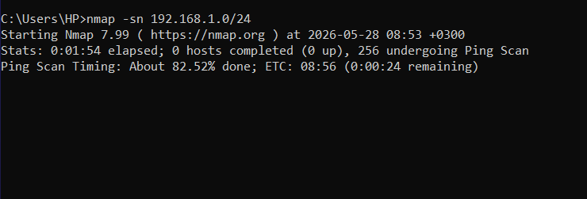
Figure 7 port scanning Nmap.org
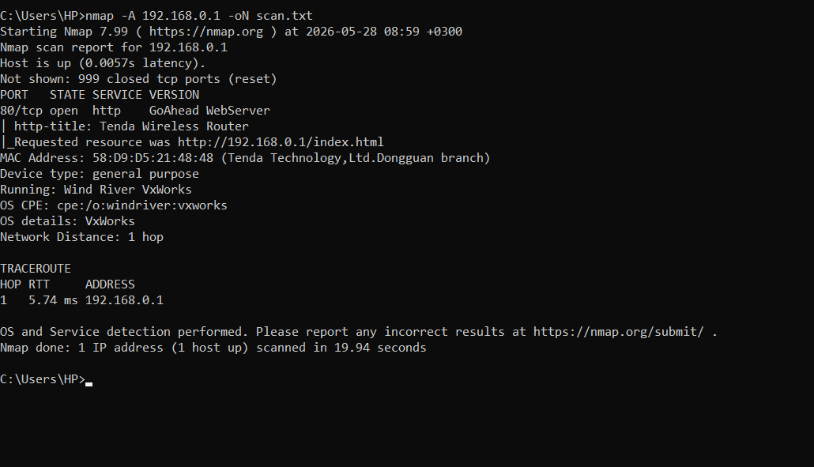
Figure 8 Nmap Report

WEEK 2

Security and Enumeration
ECITIZEN WEBSITE
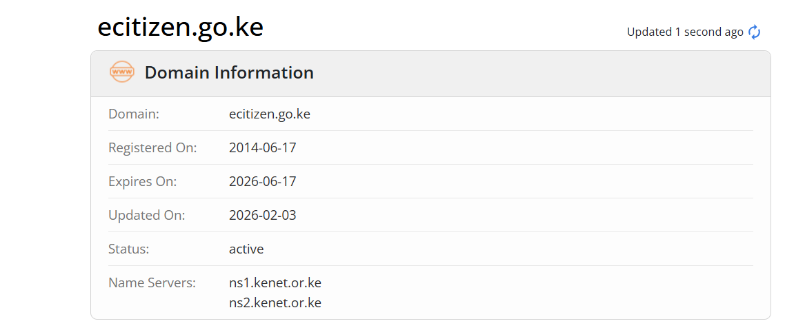
Figure 9Domain Information
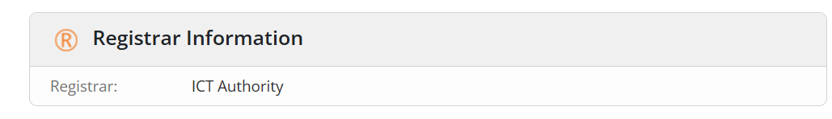
Figure 10:Registra Information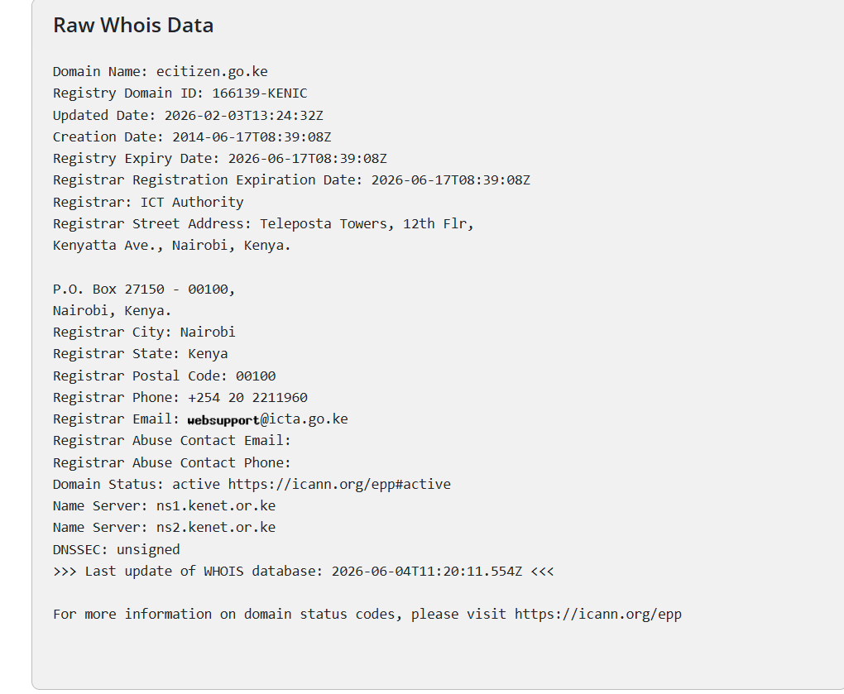
Figure 11Raw Data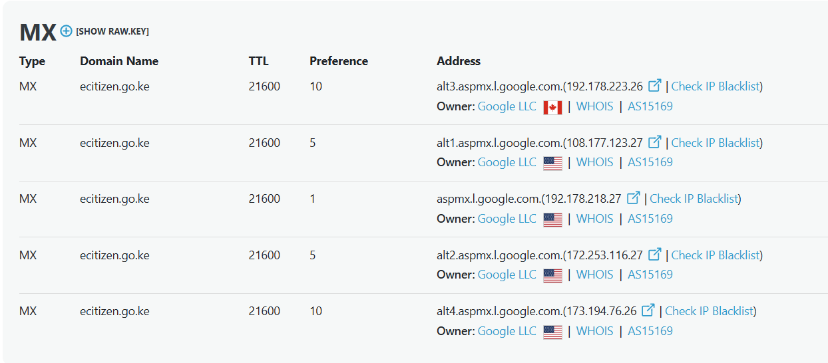
Figure 12:DNS LOOKUP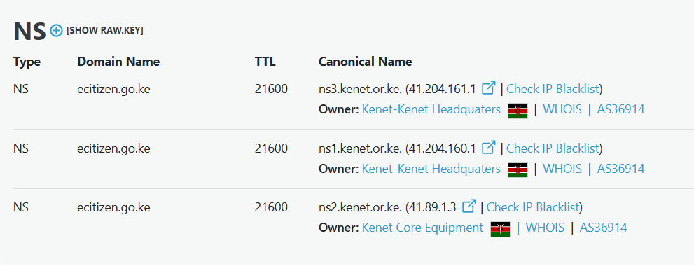
Figure 13:NS LOOKUP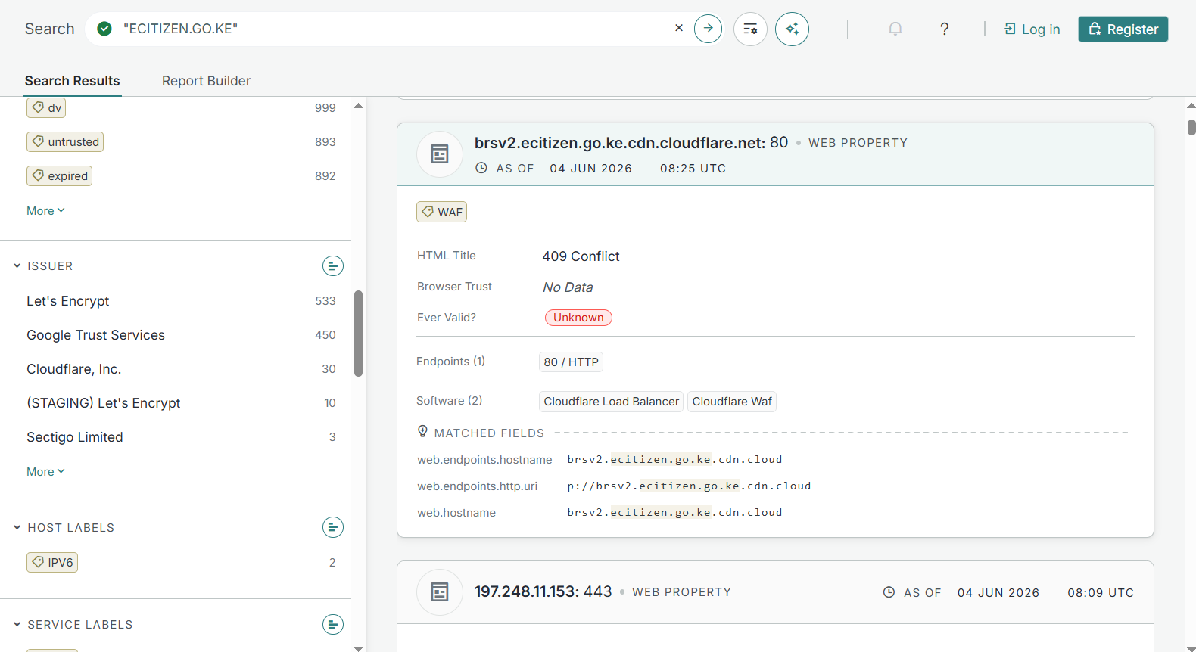
CLOUDFLARE ECITIZEN CERTIFICATE
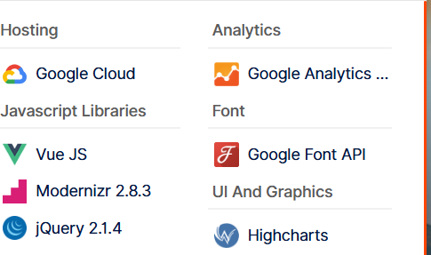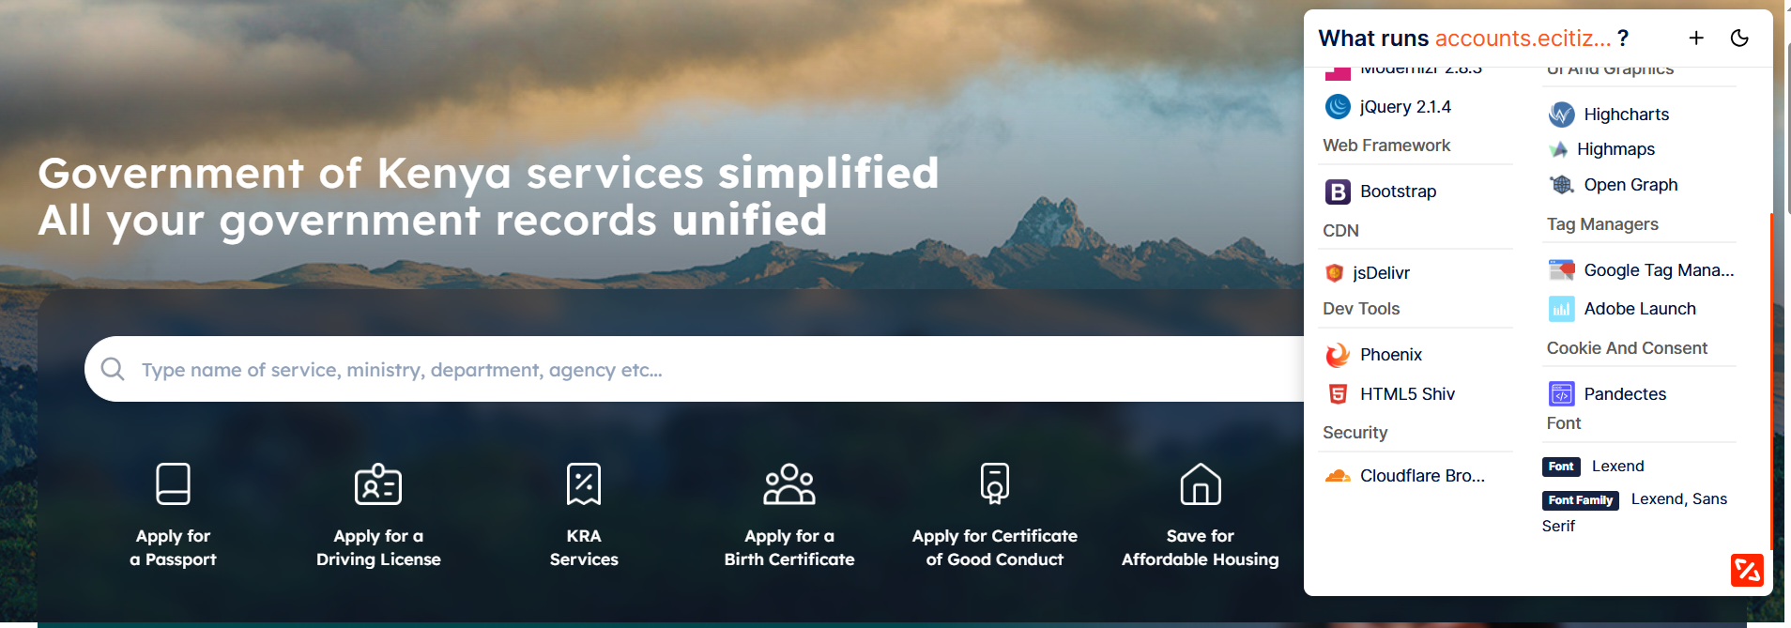ECITIZEN TECHNOLOGIES

